| **Ex. No. 7** | **JQuery** |
| --- | --- |
| **Date of Exercise** | **12/10/2022** |
| **Web Host Link** | <https://github.com/Manudhas9385/Experiment-7> |
| **Youtube Link** | <https://youtu.be/jcF4wao1IOs> |

**Aim :** To create web pages using various JQuery Effects, Elements and traversing in Jquery

**Description :**

**Add Element :**

* append() - Inserts content at the end of the selected elements
* prepend() - Inserts content at the beginning of the selected elements
* after() - Inserts content after the selected elements
* before() - Inserts content before the selected elements

**Remove Elements**

* remove() - Removes the selected element (and its child elements)
* empty() - Removes the child elements from the selected element

**Traversing**

* he <div> element is the**parent** of <ul>, and an **ancestor** of everything inside of it
* The <ul> element is the **parent** of both <li> elements, and a **child** of <div>
* The left <li> element is the **parent** of <span>, **child** of <ul> and a **descendant** of <div>
* The <span> element is a **child** of the left <li> and a **descendant** of <ul> and <div>
* The two <li> elements are **siblings** (they share the same parent)
* The right <li> element is the **parent** of <b>, **child** of <ul> and a **descendant** of <div>
* The <b> element is a **child** of the right <li> and a **descendant** of <ul> and <div>

**JQuery Effects:**

| **Method** | **Description** |
| --- | --- |
| animate() | Runs a custom animation on the selected elements |
| clearQueue() | Removes all remaining queued functions from the selected elements |
| delay() | Sets a delay for all queued functions on the selected elements |
| dequeue() | Removes the next function from the queue, and then executes the function |
| fadeIn() | Fades in the selected elements |
| fadeOut() | Fades out the selected elements |
| fadeTo() | Fades in/out the selected elements to a given opacity |
| fadeToggle() | Toggles between the fadeIn() and fadeOut() methods |
| finish() | Stops, removes and completes all queued animations for the selected elements |
| hide() | Hides the selected elements |
| queue() | Shows the queued functions on the selected elements |
| show() | Shows the selected elements |
| slideDown() | Slides-down (shows) the selected elements |
| slideToggle() | Toggles between the slideUp() and slideDown() methods |
| slideUp() | Slides-up (hides) the selected elements |
| stop() | Stops the currently running animation for the selected elements |
| toggle() | Toggles between the hide() and show() methods |

**Question 1 :**

Car moving animation using Jquery

**Program :**

<!DOCTYPE html>

<html>

    <head>

        <title>Moving Car</title>

        <meta charset="UTF-8">

        <meta http-equiv="X-UA-Compatible" content="IE=edge">

        <meta name="viewport" content="width=device-width, initial-scale=1.0">

        <title>Document</title>

        <script src="https://ajax.googleapis.com/ajax/libs/jquery/3.6.0/jquery.min.js"></script>

        <script>

            $(document).ready(function(){

                $(document).keydown(function(event){

                    var car = $('#car')

                    var arrow = {left: 37, up: 38, right: 39, down: 40 };

                    switch(event.which){

                        case arrow.right: car.css('transform','rotate(360deg)');

                                          car.animate({left:'+=5px'},1);

                                          break;

                        case arrow.down:  car.css('transform','rotate(90deg)');

                                          car.animate({top:'+=5px'},1);

                                          break;

                        case arrow.up:    car.css('transform','rotate(270deg)');

                                          car.animate({top:'-=5px'},1);

                                          break;

                        case arrow.left:  car.css('transform','rotateY(180deg)');

                                          car.animate({left:'-=5px'},1);

                                          break;

                    }

                    var car = $('#car');

            var car_pos = $('#car').position();

            var l = car_pos.left;

            var t = car_pos.top;

            if (l > 0 && l < 268  ) {

                if(t < 85 || t >250)

                    {

                        $('#car').fadeOut('slow');

                        $('#car').fadeIn('slow');

                    }

            }

            if (l >470) {

                if(t < 85 || t >250)

                    {

                        $('#car').fadeOut('slow');

                        $('#car').fadeIn('slow');

                    }

            }

            })

        })

        </script>

        <style>

            *{

                margin: 0px;

                padding: 0px;

                box-sizing: border-box;

            }

            .r1 {

                  position: fixed;

                  z-index: 0;

                  top:0px;

                  width: 200px;

                  height: 800px;

                  left: 40%;

                  background-color: black;

            }

            .r2{

                position: fixed;

                top:100px;

                z-index: 1;

                width: 100%;

                height: 200px;

                background-color: black;

            }

        </style>

    </head>

    <body>

        <div id="car" style="position:absolute;z-index:3;left:5px; top:100px;width:80px;height:50px;">

            <img id="car" src="car.jpg" alt="" width="80" height="50">

        </div>

        <br>

        <div class="r1"></div>

        <div class="r2"></div>

    </body>

</html>

**Output**



**Question 2 :**

Create a dynamic Registration form and display it in the same page using JQuery

1. Use Dom_get and dom_set to the set the values to the form

2. Dynamically add buttons and remove buttons

3. Use traversing function to display dynamically generated value in the result display portion

**Program :**

<!DOCTYPE html>

<html>

    <head>

        <title>Registration Form</title>

        <h1>Registration Form</h1>

        <script src="https://ajax.googleapis.com/ajax/libs/jquery/3.6.0/jquery.min.js">

        </script>

        <style>

            .ancestors * {

              display: block;

              border: 2px solid rgb(189, 15, 15);

              color: rgb(217, 35, 35);

              padding: 5px;

              margin: 15px;

            }

            </style>

        <script>

            $(document).ready(function(){

                $("#add").click(function(){

                    $('#out').append("Name : " + $('#name').val() + "<br>Reg.No : " + $('#Reg').val() + "<br>");

                });

                $("#remove").click(function(){

                    $("#div").remove()

                });

            });

        </script>

    </head>

    <body>

        Name :   &nbsp; &nbsp;    <input type="text" id="name"><br><br>

        Reg.No. : <input type="text" id="Reg"><br><br>

        <div class="ancestors" id="div">

            <p id="out"> </p>

        </div>

    <button id="add">Append text</button>

    <button id="remove">Remove text</button>

    </body>

</html>

**Output :**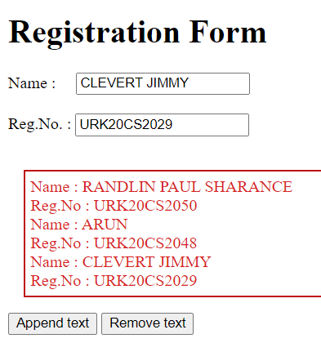

**Question 3 :**

Create a car body workshop using JQuery where in you should be able to change the color of the car, glass tint, size of the tyres.

**Program :**

<!DOCTYPE html>

<html>

    <head>

        <script src="https://ajax.googleapis.com/ajax/libs/jquery/3.6.0/jquery.min.js"></script>

        <meta name="viewport" content="width=device-width, initial-scale=1">

        <style>

            .trapezoid{

                border-bottom: 50px solid #555;

                border-left: 25px solid transparent;

                border-right: 25px solid transparent;

                height: 0;

                width: 125px;

            }

            .circle{

                height: 50px;

                width: 50px;

                background-color:rgb(45, 189, 189);

                border-radius: 50%;

                display: inline-block;

            }

            .rectangle{

                height: 50px;

                width: 250px;

                background-color: aquamarine;

            }

        </style>

        <script>

            $(document).ready(function(){

                $("#body_col").click(function(){

                    var red = Math.floor(Math.random()*255);

                    var blue = Math.floor(Math.random()*255);

                    var green = Math.floor(Math.random()*255);

                    var color = "rgb("+red+","+green+","+blue+")";

                    $("#body").css({"background-color": color, });

                });

                $("#tyre_size").click(function(){

                    size = "75%"

                    h = "75px"

                    w = "75px"

                    $("#tyre1").css({"border-radius": size, "height": h, "width": w, })

                    $("#tyre2").css({"border-radius": size, "height": h, "width": w, });;

                });

            });

        </script>

    </head>

    <body>

        <h1>Trapezoid CSS</h1>

        <div class="trapezoid"></div>

        <div class="rectangle" id="body"></div>

        <div class="circle" id="tyre1"></div>

        &nbsp;&nbsp;&nbsp;&nbsp;&nbsp;&nbsp;&nbsp;

        &nbsp;&nbsp;&nbsp;&nbsp;&nbsp;&nbsp;&nbsp;&nbsp;&nbsp;&nbsp;

        &nbsp;&nbsp;&nbsp;&nbsp;&nbsp;&nbsp;&nbsp;&nbsp;&nbsp;&nbsp;&nbsp;&nbsp;

        <div class="circle"id="tyre2"></div><br>

        <button id="body_col">Body Colour</button>

        <button id="tyre_size">tyre size</button>

    </body>

</html>

**Output :**

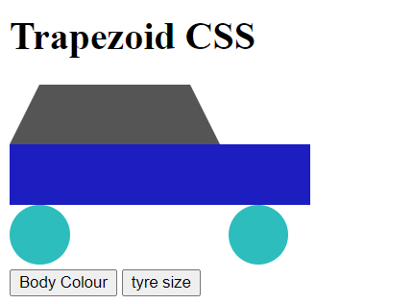

**Result :**

The above program is executed and verified successfully.